Weeknotes Journal

During the first year of Public Square we wrote weeknotes to share our progress and capture some of our learning as we went. These captured our work with four councils across the UK.

Here you can find our weeknotes from across this year of Public Square. As we moved into a focus on writing up our findings and a different year of activities we announced the end of our regular weeknotes.

How did we use weeknotes?
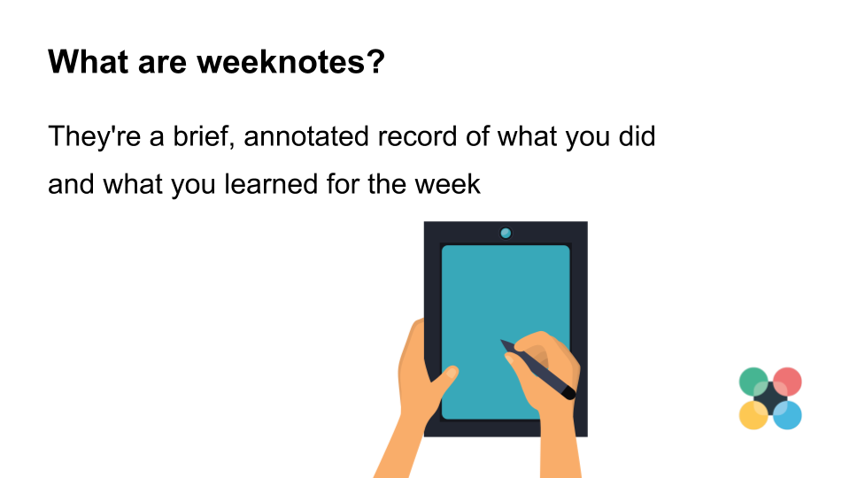
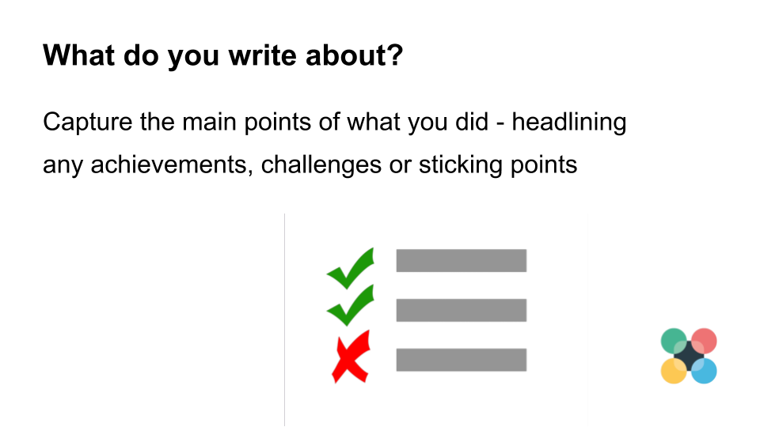
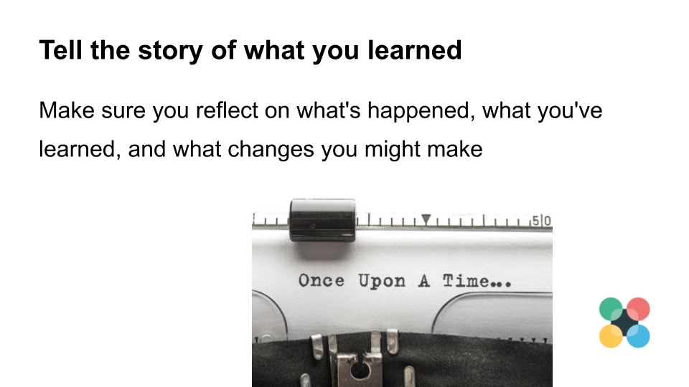

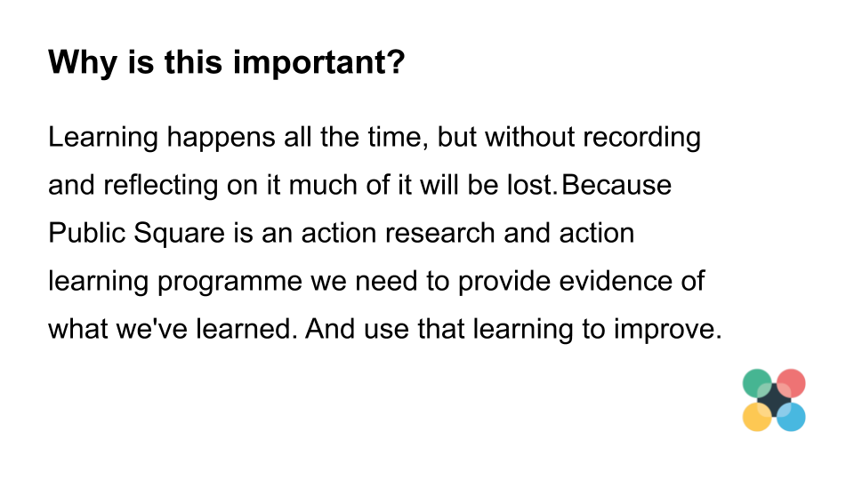

Weeknotes 19/09/19

Headlines
- This week, we’re really busy getting everything prepared for a Participatory Budgeting event in Frome with Frome Town Council on Sunday.
- We’re starting to work with Glasgow to look at a narrative for the project, to ensure it makes sense and is relatable to people from the community, council officers, and elected members for example.

Last week…
- We developed plans for our Frome workshop
- Continued to agree plans with Glasgow City Council

This week we will…
- Carry out a Participatory Budgeting event this Sunday in Frome. This will bring a randomly selected pool of citizen volunteers together to shortlist proposals ahead of their Town Vote. We’ll be sharing more about how the event works afterwards. We are also asking our participants a bit about their attitudes to taking part, and will be sharing the results. We’re excited to explore and test the approach.

What we’re thinking…
- We’re trying to bring together our programme partners to map out a way forward for phase two of the Public Square programme – how it can add most value to the sector and make the biggest impact.

And finally…
- Some of you might be involved in supporting the commissioning of or design of a citizens’ assembly. This week The Democratic Society and The RSA produced a guide to reporting on citizens’ assemblies – ensuring they are a transparent and trusted process by all!

Weeknotes 09/09/19

Headlines
- This week we are working with Frome Town Council to support the design of their participatory budgeting process – with community-level decision-making built in to the idea refinement stage.
- We’re also working with Glasgow City Council to map our next steps for the programme as we edge closer to being able to finally talk about what we’re working on together!

Last week…
- We supported Glasgow City Council to prepare for a service managers meeting – by providing outputs and materials from our initial scoping/idea generation workshops in late July. This meeting was to agree internal capacity management and resources required for the next stage.
- We also took some downtime from Public Square to recharge our batteries and focus on some other key project delivery that was required from teams!

This week we will…
- Be planning an update to go out to our Technical Reference Group to let them know the current stage of the programme and likely next steps – and get their thoughts about what our ‘playbook’ should look/feel like.
- Agree next steps with Glasgow City Council and sign-off our project brief.
- Support Frome Town Council in the development of their participatory budgeting process – through the design stage of idea refinement.

What we’re thinking…
- We’ve seen some really interesting reading be released by our friends at Nesta this week – and it’s got us thinking about where there might be similarities between our work and their People Power programme. It’s got us inspired by knowing that change is happening right across the UK and there are lots of agents of change (with Public Square being one) within the wider ecosystem of citizen participation.
And finally…
- Make sure you read this Twitter thread from Demsoc about all the reasons to be cheerful. Especially recommended if you’ve been feeling overwhelmed about the current state of affairs of democracy – locally or nationally.

Weeknotes 02/09/19

Headlines
- Preparing for PB shortlisting event in Frome
- Training workshop in Calderdale
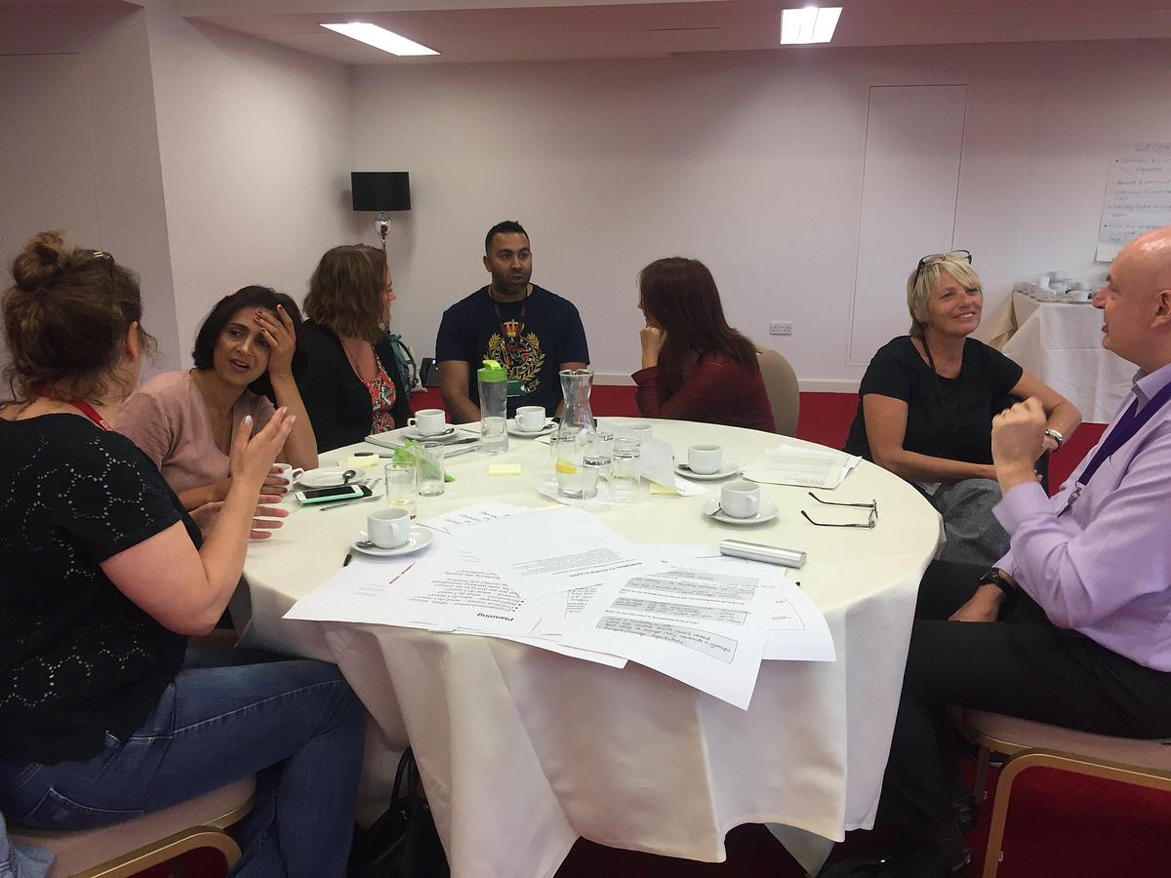A listening training exercise in progress at the Calderdale Engagement Training

Last week…
- We carried out a training workshop in Calderdale to help prepare those who will be delivering conversations with residents. Working through the stages of plan, do, and learn/review. This included thinking about listening skills and identifying any unmet learning needs.
- We are now at a stage where we’ll be less heavily involved as the council start to put these conversations in action. Though as these conversations happen we’ll be hearing reflections about how well or not the prototypes have worked – we’ve created a learning and reflections form that will be used to capture these. You can see (and comment on) a template of the learning and reflections form, if its useful to adapt for your own practice.

This week we will…
- Prepare for a Participatory Budgeting shortlisting event in Frome, where we will be asking a group of citizens to shortlist ideas for how the town council can best spend £10,000. In particular we are making sure we can gather enough information beforehand about the proposals being considered. At the event we are going to be asking our participants to consider the feasibility, impact and equity of the public’s ideas, so we’ll need to make sure we have enough information about each idea beforehand.
- We’ll also be using this event to ask participants a bit about what made them get involved, and about what the event was like for them. We are currently planning this research and evaluation.

What we’re thinking…
- Last week was a difficult week for UK democracy. It’s increasingly vital that those of us who value democracy are willing to treat it as more than just an abstract concept and express why it’s important and what it looks like when its working well.

And finally…
- When thinking about delivery in different places, it is important to consider and understand how these contexts differ. We all have experience of things working well in one scenario and then seeing it not achieve the same results in another. mySociety are used to exploring the demographics of who uses their services, and have now applied these approaches to local authorities. This helps show how different councils compare.

Weeknotes 26/08/19

Headlines
- Delivery of community engagement training in Halifax
- Getting YourPriorities launched, and starting to plan an in-person idea sifting event in Frome.

Last week…
- Making sure all materials were prepped and facilitators were briefed so we could deliver effective training for Calderdale Council colleagues and residents who will be part of delivering the ‘Calderdale Conversations’ programme (developed with us!)
- Sharing final outputs from our workshops a few weeks ago in Glasgow with our delivery partners as we look to move into the next phase of our programme there.
- Ironing out a few last minute hitches in getting the ideas that people have had for the People’s Budget in Frome onto YourPriorities with the help of the Citizens Foundation, and starting to plan for getting residents involved in picking the ideas that will go forward to the final vote.

This week we will…
- Deliver two back-to-back community engagement training sessions in Halifax. This is for a range of council colleagues and residents/volunteers and partner organisations in the Calderdale area who have been involved in co-designing the prototype tools to be used for having conversations with local people in communities. Around 50 people are attending over the two 3.5 hour sessions where we’ll be focusing on how to plan, do, review and learn in practice. We’ll also be thinking about ensuring safe and effective engagement delivery.

What we’re thinking…
- We’re beginning to sift through lots of examples we’ve been gathering over recent months of other playbooks in different fields and think about how ours might used to make it as effective as possible. We’re also pulling together existing resources and documents we have to begin finding out what we might be missing and then develop a ‘rough-cut’ of our playbook’s structure.

And finally…
- Preparation, preparation, preparation – and then reflection – equals success.

Weeknotes 19/08/19

Headlines
- Getting materials and facilitation plans finalised for a training workshop in Calderdale.
- Checking everything is ready for the launch of a Your Priorities site in Frome.
- Doing research on previous online participatory budgeting projects in Frome.

Last week…
- We were helping Frome set up a Your Priorities site.

This week we will…
- Be preparing for a workshop in Calderdale to train those who will be conducting conversations with residents. Including getting materials and facilitation guides ready.
- Be checking everything is ready for the launch of Frome’s Your Priorities site.
- Be looking into the performance of Frome’s previous People’s Budget initiatives, including their online voting results, to see what we can learn for future votes.

What we’re thinking…
- As part of Public Square we’ll be creating a playbook resource. We’ve been thinking about what makes these work well, and are interested to hear from others. We’ve just published a blog post looking at these questions.

And finally…
- Our training workshop in Calderdale is about making sure those running conversations are properly prepared. So we’ve been designing a session that covers the key things needed before starting this. We’ll be sharing more information about how we are doing this later on.

Weeknotes 12/08/19

Headlines
- Setting up Your Priorities for Frome
- Early planning of a Participatory Budgeting sift event for Frome
- Finalising plans for a training workshop in Calderdale

Last week…
- We were capturing what was heard from two days scoping out Glasgow’s involvement in Public Square.

This week we will…
- Set up the online idea generation and discussion platform Your Priorities for Frome Town Council’s Participatory Budgeting process. This is an open source tool, and we’ll be sharing more information about it as we go.
- Draft out plans for a sift event in Frome to whittle proposals down to a final shortlist for voting on.
- Finalise plans for a training workshop in Calderdale, to help prepare staff and volunteers for putting prototypes into action to run conversations with residents.

What we’re thinking…
- With Frome we’ve been discussing whether its useful to use ‘likes’ on online platforms. On one hand they can indicate levels of support, but they remain quite a crude mechanism. Rather than removing this feature, one option can be to help citizens reflect on what these show, and what they don’t. Frome are using a sift event after idea generation and this is something that can be talked through with these participants.

And finally…
- We’ve been working closely with the comms team from Calderdale as part of our work there.

Weeknotes 05/08/19

Headlines
- Scoping out how we can work with Glasgow City Council and Glasgow Life.
- Comms planning with Calderdale.
- Planning a training workshop in Calderdale.

Last week…
- Spent two days in Glasgow with Glasgow City Council and Glasgow Life to scope out our Public Square project together. We also developed a community engagement plan and look forward to further developing our plans and sharing more about our work there shortly!
- Met with the comms team from Calderdale Council to discuss plans for a website supporting their Calderdale Conversations. Next stage is mocking up a version of the site.
- Drew up plans for a training workshop for staff and volunteers interested in running these conversations.
- Explored with Frome Town Council what online ideation generation for Participatory Budgeting could look like using the Your Priorities platform.

This week we will…
- Write up data from our Glasgow workshops.
- Work to ensure we have a good number of resources being developed and shared through our Public Square channels – such as blog posts, podcasts, links to great resources we’ve come across. We’re going to do some work on our communications calendar to make sure we’re getting it right.

What we’re thinking…
- It’s sometimes just like watching magic happen when we bring a room full of people together, who share different views and wear different ‘hats’; seeing what is developed by working together is brilliant. We’re delighted to be able to create the opportunities and spaces for this to happen through Public Square within local government – and we’re excited to share with you over the coming weeks the details of what we’ll be up to in Glasgow.

And finally…
- All over the world, many different organisations are trying out many forms of participatory democracy— and we can all benefit from following each others’ experiences. To make it easy to keep up with the news from every quarter, we’ve put together a Twitter list.

Weeknotes 29/07/19

Headlines
- Creating resources for capturing learning and reflections in Calderdale.
- Planning communications and web presence for Calderdale Conversations.
- Scoping conversations in Glasgow.

Last week…
- We pulled the prototypes and engagement plan developed through our co-design workshops in Calderdale into a form for the council to start building upon and putting into use. We also created a content capture form for staff and volunteers to record what’s heard in Calderdale Conversations across the borough. And created a learning and reflections form for those using prototypes to capture learning about how well these prototypes work and how they can be improved on.

This week we will…
- Run scoping meetings in Glasgow to plan out how we’ll be working with the council there.
- Have a comms planning session with staff from Calderdale Council, thinking about how we communicate about the conversations the council is running and how to make best use of a web presence as part of this.
- Think about the best way to capture case studies about our work with council partners.

What we’re thinking…
- We are interested in how elected members feel about involving people more closely in decision-making. We are planning to carry out some research into this. You can read more here.

And finally…
- Last week we published a blog about Demsoc’s work in Messina. This project is interesting because of its focus on building change from the bottom up.

Weeknotes 22/07/19

Headlines
- We’re getting prepared for an intensive two days working in Glasgow with Glasgow City Council and Glasgow Life to develop their programme of work with Public Square – looking at scoping, decision-mapping, community engagement planning and more!

Last week…
- We’ve been capturing outputs from our second Calderdale co-design workshop, ready for sharing back.
- Continuing to develop plans for the PB process in Frome, particularly thinking about online ideation and how best to sift and develop unformed ideas.

This week we will…
- Meet with Dr Nikki Soo, Research Associate at the Crick Centre to discuss opportunities for sharing some of their research outputs on our website. Nikki might also write a blog for us about the research she is undertaking around understanding the term ‘The Public’ and we’ll share this in September – keep your eyes peeled.
- Have an internal synthesis session to reflect on what was heard at our co-design workshop in Calderdale and plan next steps.

What we’re thinking…
- We talked through a lot of what needs weighing up to design a good PB process this week. Hopefully we’ll share some of what was discussed soon.

And finally…
- It’s not just local government who are looking to create more opportunities for meaningful citizen participation in decision-making – national governments are too. We have had some interest from national government in Wales and Scotland about our work; particularly about how our learning could help facilitate opportunities for civil servants developing policy with citizens.

Weeknotes 18/07/19

Headlines
- Second co-design workshop in Calderdale
- Thinking about inclusion online and offline with our partners in Frome

Last week…
- We ran our second our co-design workshop in partnership with the council in Calderdale. We used the open source tool scenes to help our group of council staff, partners and citizens think through what our four prototypes from the first workshop could look like in the real world. And we asked our group to think about opportunities for using them to reach particular groups, making a start on an engagement plan. Already one of them – a listening sofa – has been tried out over the weekend. We’ve published a blog about the workshop.

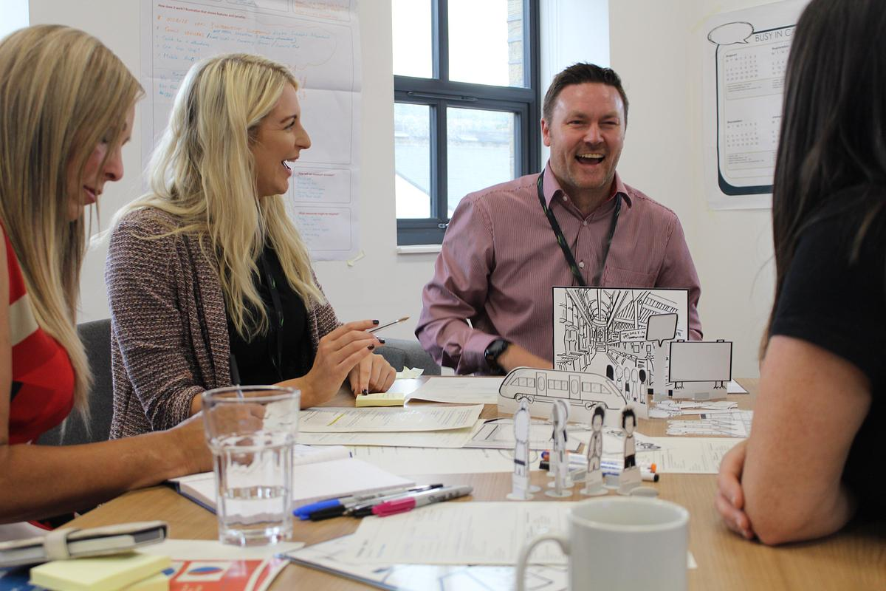

This week we will…
- Be writing up outputs from the workshop which we will then be analysing and presenting back to the council and those involved in the workshops.
- Continue exploring how a playbook type resource could help people design better local participation in democracy – including drafting a case study of good practice for designing democratic participation.
- Think about the design for a PB process in Frome. In particular how to move from quickfire ideas towards a small number of options for a vote in a way that is informed, fair, transparent and gives a greater role to communities.

What we’re thinking…
- In Frome we’re thinking about how to involve citizens in the filtering of ideas in an impartial way. One of the approaches we’re looking at is the selection criteria used by the PB Project in New York City. You can read more about PB in NYC in this blog.

And finally…
- We are thinking about how to share more about the work we are doing, and more widely. Each week we’ll be drawing from these weeknotes to think about what we should be sharing in more depth. Hopefully you should soon see the results.

Weeknotes 08/07/19

Headlines
- Designing a co-design workshop
- Planning for wider participation

Last week…
- We’ve been designing this week’s co-design workshop in Calderdale, where we’ll be working with residents and council staff to design how the council can build open conversations with its residents about the future of their borough. We’ll be using the free resource ‘scenes’ to help participants think about some prototypes generated at the first workshop, and will be working on how these can be put into practice.
- We started to plot out a timeline for our work with Frome over the course of the summer to help them get ideas from a wider group of people for their People’s Budget.
- We read Nesta’s report on using digital tools to enhance the work of Parliamentary select committees and grow public engagement with Parliament. The recommendations Theo Bass makes for digital participation in select committees: like focusing on clear goals, defining the stakeholders carefully, and making the rules of engagement for participation clear, feel broadly relevant to local government too.
- We talked to Pat Scully and Graham Smith, of Participedia about how our playbook prototype could contribute to and reference Participedia, rather than duplicating effort.

This week we will…
- Be running a second co-design workshop in Calderdale, as mentioned above. These intro slides for the workshop give an outline of what we’ll be doing.
- Thinking about simple mechanisms and simple language for asking people to submit ideas online for a participatory budget.

What we’re thinking…
- Something we’ve been looking at this week is the technique of rough consensus in decision making – a way of coming to decisions that everyone can live with that has a lineage from the Society of Friends, through the IETF and into large scale online deliberative processes like vTaiwan.

And finally…
- Last week some of the team from mySociety and The Democratic Society were at the Local Government Association Conference. Some great conversations were had. You can catch up on what happened at the conference through the hashtag #LGAConf19.

Weeknotes 01/07/19
Headlines
- We’re working on three prototypes for our next citizen engagement workshop in Halifax with Calderdale Council next week. The prototypes we’ve developed are as a result of our initial engagement where citizens designed the physical tools to use, starting this summer, to have conversations about place with communities.
- As part of our work with Frome, we’ll be doing some research on approaches to reaching beyond the usual participants when asking for ideas online
Last week…
- We continued to develop our Playbook to support good quality citizen participation. We have started a prototype of what we expect this could look like.
- We started to collate examples of good participation design to support our iterative and ‘thinking in the open’ principles. If you know of any, send them our way, please!
- We also developed a list of questions that we often get asked when working within local authorities; usually about the design and management of participative democracy activities. This will help us best meet the needs of our local authority colleagues in the on-going development of our Playbook; to make it as useful as possible!
This week we will…
- Begin to evaluate different participation models and weigh up the challenges and advantages of wide range of techniques.
- Further develop the ‘Resources’ section of our website – building up a bank of useful resources we come across that we think would help inform other people’s knowledge too.
What we’re thinking…
- When working within a local authority environment, it’s important to involve and get views from a wide range of officers to ensure we uncover all of the experiences, learning and networks within an area. One officer might have the ‘golden nuggets’ of information which can aid a participative design process.
And finally…
- Some of our team from mySociety and The Democratic Society are currently at the Local Government Association Conference this week in sunny Bournemouth! If you’re around, and would like to hear more about Public Square, come and see us at ‘The Democracy Hub’, stand P71. If you can’t make it, you can follow the conference at #LGAConf19.

Weeknotes 24/06/19

Headlines
- Comms workshop in Calderdale last week
- First prototype of a playbook format for local authorities

Last week…
- We took part in a really productive workshop, led by staff from Calderdale council, to develop clearer messages about the conversation they want to have with residents at the end of the summer. We considered this up by thinking what looks different in the borough if this conversation works well. The council will be creating some messaging from here.
- Alex finished up work on a review of digital tool use around Citizens’ Assemblies
- Beginning to map out councillor attitudes research project (more in a future blog post)
- Zarino produced an early stage prototype for a playbook on participation for people working in local government

This week we will…
- We are creating a plan for the second co-design workshop in Calderdale, in which we’ll be showing some models of the earlier prototypes and moving towards an engagement plan for the summer.

What we’re thinking…
- As frequent facilitators it was an interesting change to take part last week in a workshop that was led by a council and hosted in Demsoc’s Manchester offices. This may well have allowed us to play a slightly different role in discussions than when we are the facilitators. Those of us who work on improving democracy are often in the room in the position of facilitators and it’s interesting to think how this might be shaping the way that our field is talked about.

And finally…
- Someone we spoke to this week was interested in understanding more about co-production, which is an important part of our approach. There’s lots of information out there, one good place to start is the knowledge base created by Co-Pro Network Wales.

Weeknotes: Comms workshop with Calderdale, 17/06/19

Headlines
- A comms workshop with Calderdale Council
- Early stage playbook thinking
- Conversations with practitioners about developments in the field of participation
- Drawing our theory of change

Last week…
- Louise and Zarino made a proposal to the team about what a first version of the playbook might look like – a practical resource for people working in and with local government, driven by some form of self-assessment
- Agreed some desk research around a key issue in the work so far – the role of elected representatives and their relationship to participatory research
- Had a great conversation with Matt Leighninger of Public Agenda and Participedia and got some good pointers on further reading and opportunities to work in complementary ways to other projects
- A couple of us attended a practitioner conversation around the increasing demand for Citizens’ Assemblies and other deliberative processes
- Started to design a plan for phase 2 of Public Square, how people can get involved, potential avenues for funding, ways we can share the learning more widely

This week we will…
- Take part in a workshop with Calderdale comms team – Calderdale Council are planning a conversation that launches this summer about what a 21st Century social contract might be between residents and the council. How to describe this in a way that people can and want to engage with needs some thought.
- Publish our lines of enquiry from our Learning Strategy. We are particularly interested in who else is exploring these areas so that we can link this into our playbook.

What we’re thinking…
- One of our aims in this programme is to create a resource that can help people who are trying to design and build a more participatory local democracy. Our hope is that the playbook not only informs, but can support people with designing their steps forward. We’ve been starting to think about what this might look like, but are also hoping to speak to others about what sorts of things would be useful.

And finally…
We note with interest the commitment in the OGP action plan for the Netherlands 2018-2020 that outlines experiments in digital participation approaches in local government, including the question of “which criteria successful participation tools should comply with.” This is something that feels like an important thing to think about in driving the field forwards.
P.S. – we are going to be at the Local Government Association Conference in Bournemouth this year, (2nd – 4th July) Come and find us at the Democracy Hub, we love to hear what others are doing.

Weeknotes 09/06/19

Headlines
- Learning review day with Luminate last week and moving forward with Calderdale.

Last week…
- We had a learning review day with our funders, Luminate. It helped us to clarify some of our immediate needs on the programme, including preparing a pitch-pack for potential funders for the next stage of the programme.
- We’ve been continuing to develop prototypes from the ideas that workshop participants shared about how to build a conversation over the summer in Calderdale.

This week we will…
- Work on the communications for Public Square – in preparation for the pitch pack
- Talk about complementary research approaches to our work with councils
- Prepare for a comms workshop for Calderdale, to be held next week.

What we’re thinking…
- Following our learning review meeting, thinking about what a useful playbook for participation might look like and trying out some ideas
- Wondering what the best way is to collect all the examples of extraordinary participation in UK councils
- How we can get some forward thinking UK local government policy makers along to G1000’s Summer School on Deliberative Democracy for Ambitious Policy-Makers

And finally…
- This programme gives us a great opportunity to speak to interesting people who are trying to improve local democracy, and showcase what others are working on. If you are trying to improve local democracy, and have a story we could help you share, get in touch – it would be great to hear from you. You can get in touch through: team@thepublicsquare.org.uk

Weeknotes 03/06/19

Headlines
- We’ve been writing up, and building from, the ideas heard at our Calderdale co-design workshop.
- This week we have a learning review day workshop with our funders Luminate to talk through how the project has gone so far and what we want to do as a result

Last week…
- Had a bank holiday!
- Wrote up what we heard from participants at our co-design workshop in Calderdale about ways the council can engage differently with residents. This will be shared back with participants by the council.
- Made a start on developing prototypes of how Calderdale Council could engage with residents, building on the ideas of these participants. We’ll share these ideas (and a summary of these conversations) on our blog soon.

This week we will…
- Continue to develop prototypes from our conversations in Calderdale last week.
- Reflect on the project so far with Luminate, and think about what that means for next steps
- Start to plan for sharing more of our work online – what elements would be useful to others, and in what form

What we’re thinking…
- Working with local government requires thinking about lots of different groups: different departments within the council; those at the frontline alongside those with a more strategic focus; councillors as well as officers – let alone the diversity of people with an interest in a project outside the council. And all these groups are made up of people with different personalities and outlooks. The diversity within councils is something people outside them don’t always see. It’s interesting to think what would change if people outside the council were more aware of this diversity.

And finally…
- Next Monday Mel Stevens from the Public Square team is looking forward to taking part in FutureGov’s ‘Designing 21st Century Government’ event in London. If you’re there come and say hello.

Weeknotes 27/05/19

Headlines
- Two days of intensive work with Calderdale Council in Halifax. This involved a stakeholder/citizen co-design workshop on Thursday and some fantastic meetings on Friday.
- Conversations with councillors in Frome.

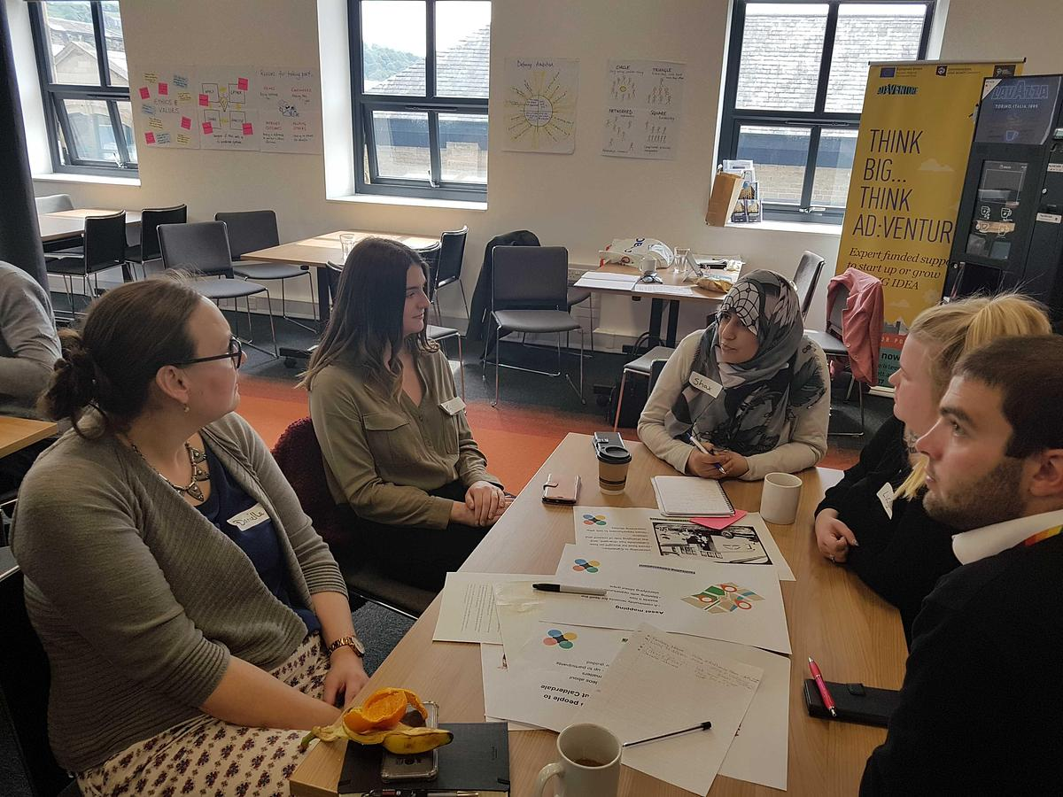
A table discussion at the Calderdale Co-design Day

Last week…
- We also enjoyed two days in Halifax working with Calderdale Council and citizens on their Public Square project. This included working with community groups to prototype ways to talk about the relationship residents have with Calderdale, the council and the place.
- We also discussed ways of doing Participatory Budgeting in Frome, in conversation with town councillors. We talked about how to design the process with the wider community and conducted interviews with councillors to learn more about the context we’ll be working in.

This week we will…
- Continue to work on our delivery plans for our council partners
- Start to develop prototypes from the ideas that were developed at the Calderdale co-design workshop last week.
- Make arrangements for our learning review meeting – that will take place next week and include our funders, Luminate.

What we’re thinking…
- We were blown away by the sense of pride people had for their local area in Calderdale. This came through loud and clear in the workshops, where residents from a range of ages, backgrounds and experience shared their thinking and vision for Calderdale, plus the sights they showed us!
- An interesting challenge that we heard about this week was how best to involve community groups in promoting a democratic engagement without those same groups gaining an advantage in that engagement? This is a tension we’ll be thinking about further.

And finally…
- This week we give a big warm welcome to Simon Cameron, Development Manager – Participatory Budgeting, at the Convention of Scottish Local Authorities (COSLA) to our Technical Reference Group. Welcome, Simon!

Weeknotes 20/05/19

Headlines
- Project call with Frome Town Council – we’re sharing and discussing various tools and items of reference as we look to design a solution for Frome’s Town Vote.
- We’ve got a busy two-days in Calderdale! On Thursday we’re working with Calderdale Council to facilitate a co-design workshop with some key stakeholders (including citizens) and on Friday we’re meeting with and sharing the story of Public Square in Calderdale with senior officers and elected members. We’re super excited!

Last week…
- Met with the lead officer at Glasgow City Council who is our main contact for developing our Public Square work. We worked really hard together to delve into the issues that the Public Square project could address, including helping the council to ‘tell the story’ of engagement and participation at a community level.
- We then took part in a work group meeting with several senior officers from Glasgow City Council and Glasgow Life, including elected members. This was to give a bit of an overview about who we are and how we are hoping to work with Glasgow City Council to develop their project. We discussed key activity, centred around the city’s People’s Palace, and activating, involving and empowering citizens to think about its future use as a place for public deliberation and local democracy.

This week we will…
- It’s all about Calderdale this week! With our ‘on-site’ workshops on Thursday and Friday.
- But we aren’t forgetting about our other council areas and have a meeting with Frome tomorrow to discuss the scope and technical requirements of their project, including starting to plan some co-design activity with them.
- We’ll also be following up on some of our actions from our meetings with Glasgow last week.
- We’ve also published a blog introducing Calderdale Council, which explains more about our work with them so far. Go take a look if you’ve still got time.

What we’re thinking…
- Local knowledge is key – citizens hold their local knowledge as something which is very important to them. And rightly so! We are developing our plan of action to implement some ‘community reference groups’ around our four council areas – groups of local people who can influence the projects as they go, but also provide required insight and knowledge from their perspective.
- The community reference groups (name to be agreed!) will have a key role to play which focuses on their local projects – but will also come together as larger groupings to share learning, expertise and opportunity within and for the other areas. We can’t loose people’s expertise about their communities as part of the bigger programme…

And finally…
- Mel and Kevin, two members of the team, were delighted to meet with Oliver Escobar last week in Edinburgh. Oliver is a member of our Technical Reference Group and provided some great insight into some of our ‘thorny issues’ we’ve been mulling over ourselves. It always helps to be surrounded by brilliant critical friends!

Weeknotes 13/05/19

Headlines
- Designing a Co-design workshop with Calderdale Council
- Pulling together information about Participatory Budgeting and approaches to online voting for Frome
- Getting clear our approach to discovery and co-design

Last week…
- We are moving ever closer to a co-design workshop in Calderdale next week, which will bring community stakeholders together with the council to help plan a wide-ranging conversation this summer about the relationship between residents and the council. Last week we spent time designing the workshop together with Calderdale Council’s Neighbourhoods and Cohesion Manager.
- We want to help our partner councils out, by providing inspiration about new approaches. In Frome we are starting to pull together information about Participatory Budgeting to use for thinking through options for delivering a ‘Town Vote’.
- We’re also thinking about what the options are for using digital tools to facilitate a ‘big conversation’ with residents in Calderdale and how you might evaluate the success of this kind of approach.
- With some of our councils we are already making a good start on discovery research about their context and needs. In each area we hope to work with a wide range of stakeholder to design new ways of engaging in partnership. We’ve been spending time making sure everything is in order for this, and that we’ll be able to capture all our learning – including our personal reflections.
- To that end, we’re continuing to explore digital tools which exist out there which can bring about increased community participation around project idea generation. If you know of any that you think we need to know about, drop us a line!

This week we will…
- Be speaking with senior people in Glasgow City Council to agree how they’ll be involved in the programme.
- Be meeting with the Convention of Scottish Local Authorities (COSLA) to update them about the Public Square Programme.
- Be catching-up with our good friend and member of the Technical Reference Group for the programme, Oliver Escobar, to update them on our progress to date and pick their brains about some of the ‘thorny issues’ which have been exposed so far.
- Be getting everything ready for an intense week of co-design work in Calderdale the following week.

What we’re thinking…
- Co-design is going to be a really interesting, but a challenging, part of the project. We’ll be facilitating the aspirations of councils coming together with those of their communities, and sharing our own ideas about possible approaches. Alongside what we learn from the design work we expect there will also be plenty to learn about using this approach itself in this context.

And finally…
- We’re continuing to give some thought as to what ‘phase two’ of the programme looks like in delivery terms and are picking up some conversations with councils which are already keen to explore this with us. We are thinking about how to turn the outcomes of co-design into helping councils on their journey to ever-better citizen participation.

Weeknotes 06/05/19

Headlines
- Exploring digital tools for decision-making and communicating Public Square

Last week…
- Initial discussion about what our digital approach should be in Calderdale.
- Thinking about ways to use digital tools in opening up a small grant programme to wider participation.
- Starting to think about how we talk about Public Square to people who might be interested in our next steps
- Explored tools and options available to provide a solution to digital decision-making (which isn’t about participatory budgeting)
- Held the Technical Reference Group meeting – which turned into a useful project-team meeting to think about our journey so far and where we need to go next.

This week we will…
- Think about options for Calderdale for digital tools for supporting dialogue between councils and citizens.
- Identify our next steps in working with our Technical Reference Group.
- Continue engaging with to a wider group of people who might be interested in the next stage of Public Square.

What we’re thinking…
- Public Square is a large programme, spanning different areas with different local needs. We need to make sure that the outputs from Public Square are relatable to as many local areas as possible – through our reflections on learning and actions.

And finally…
Public Square is uncovering up some fascinating questions. An example – that we’re already thinking about – is how to talk about and shape the role of councillors for deliberative processes in an appropriate way, but there are many more. Over the next few weeks, we’ll start to talk more about these questions – and seek answers to them with the help of our advisors and others.

Weeknotes: Starting discovery, 23/04/19

Headlines
- Onsite discovery visit in Frome - interviews with key stakeholders

Last week…
- Spent a day in Frome shaping discovery and doing interviews with key stakeholders (Friday, 26 April).
- Spoke to Andy Paice, a public participation consultant and learned more about his work.
- Planned meeting with Technical Reference Group, to be held on 1 May.
- Developed Calderdale - and planned our onsite discovery work in May.
- User research interview and document review around council process, barriers and opportunities

This week we will…
- Take part in our Technical Reference Group meeting
- Continue to develop our discovery work onsite with Calderdale
- Reflect on our day in Frome and actioning key activities
- Make travel arrangements for our onsite visit to Glasgow in May.

What we’re thinking…
- We’re thinking about the difference between user research that looks at how to best deliver pre-set aims, and a process of design that makes space for looking more broadly at whether democratic processes are as meaningful for citizens as they could be. Making room for the latter will be a key challenge for Public Square.
- learning that there are probably at least two different forms of co-design that we need to explore. There’s co-design in terms of product design, but also co-design in terms of citizens participation and decision-making, such as when we’re looking at policy development.

And finally…
- We’re putting more thought into how to capture learning from the discovery phases in each council area and how we make that data more meaningful for our collective learning journey. More on this soon!

Our very first weeknote! 23/04/19

Headlines
- Working with councils to start discovery phases for our work with them.
- And this is our first weeknotes!

Last week…
- Finalised semi-annual report for Luminate, having submitted earlier in April.
- Started detailed discovery for councils, including project plans, briefings and research questions..
- Completed draft profiles for each of our councils, situating them along dimensions of local authority variation.
- Attended the Digital Development Group for Participatory Budgeting in Scotland – shared information about Public Square.
- Started our weeknotes!

This week we will…
- More work on discovery – including in-person discovery sessions, working through documentation and planning our visit to Calderdale Council – in May.
- Preparations for meeting later in May, with the final council to join Public Square.
- Share recent resources with the Technical Reference Group, in advance of our next with them in early May.

What we’re thinking…
- There’s a growing appetite for the work Public Square’s doing but it goes beyond councils and we need to think about how we talk in much less in jargony lingo.
- We need to invest in simple resources right away that tell the story of the work we’re doing – and help people who are outside the immediate conversations we’re having to get involved.
- There are many system challenges in relation to citizen participation. Recent discussions and hearing from community planning officials as part of a Participatory Budgeting Scotland development group have reinforced that good participatory practice doesn’t happen in silos. We’re excited to see the paradigm shift that Public Square brings within the system.

And finally…
We’re coming across a lot of great stuff going on in different places that should challenge and inform what we’re doing. Relatively recent examples include the ‘Are We Rallying Together’ event and NLGN’s The Community Paradigm work. There are loads of different angles that people are working on this topic from; something we hope to look at in a blog post soon.

